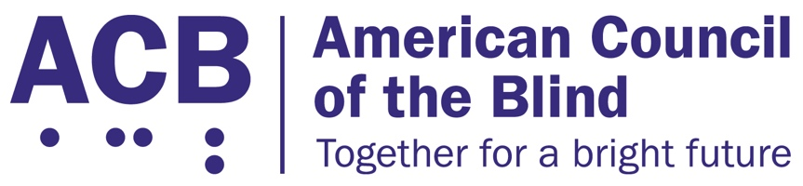
1703 N. Beauregard St., Suite 420

Alexandria, VA 22311

Tel: (202) 467-5081

Fax: (703) 465-5085

2020 ACB Legislative Imperatives

The American Council of the Blind is the nation’s leading grassroots consumer organization for individuals who are blind and visually impaired. With over 70 state and special-interest affiliates across the country, ACB is committed to increasing the security, independence, quality of life, and economic opportunity for Americans who are blind and visually impaired, and ACB stands committed to advocacy that lifts up our values.

The following legislative imperatives represent several key issues in the 116th Congress that ACB believes will help us on our road to full independence and participation in our society.

Securing Independence for Medicare Beneficiaries

For more than a decade now, Medicare has refused to cover the cost of low-vision aids, due to an eyeglasses exclusion that prohibits the purchase of any durable medical good with a lens. While the regulatory exclusion was seen as cost-saving by not covering eyeglasses, it has had a negative impact on those who, through the use of special low-vision aids, could significantly increase their independence in the home. ACB believes that adaptive low-vision aids can have a significant impact on an individual’s ability to remain independent in the home. Such personal independence would allow many individuals with visual impairments to age in place, rather than necessitating costlier institutional services.

ACB calls on Congress to support H.R. 4129, the Medicare Demonstration of Coverage for Low Vision Devices Act of 2019, which would measure the various costs and benefits of removing the Medicare eyeglass exclusion. This bipartisan legislation is a smart approach toward finding workable solutions that help seniors age in place. Offices in the House of Representatives interested in co-sponsoring H.R. 4129 should contact Kelly Hennessey in the Office of Rep. Maloney (D-NY-12), or Shayne Woods in the Office of Rep. Bilirakis (R-NY-12). Offices in the Senate interested in supporting a companion bill to H.R. 4129 should contact Madeleine Short in the office of Sen. Gillibrand (D-NY).

Pushing Forward with the Development of Autonomous Vehicles

We are now at an exciting technological place with regards to transportation. The potential for the use of autonomous vehicles for people who are blind is closer than ever. Such vehicles are already being put to the test in multiple cities. However, it is critical that these cars remain fully accessible, and that individuals who have the most to gain through such technology are not left behind.

In the fall of 2019, a bicameral, bipartisan committee inquired about the accessibility needs of disabled people as it pertains to autonomous vehicles. Since then, draft legislative language has been provided and assessed. The committee is working to include accessibility provisions in the bipartisan autonomous vehicles bill. ACB calls on the 116th Congress to move forward with autonomous vehicle legislation that ensures equal access for people who are blind and visually impaired.

Driving Forward Transportation Options for People Who are Blind and Visually Impaired

Congress must reauthorize the Fixing America’s Surface Transportation (FAST) Act by September of 2020. The FAST Act fulfills the constitutional directive that dictates that investment in transportation and infrastructure is a core federal responsibility. It oversees the development and maintenance of roads, bridges, public transit, and rails. As the language of the new bill is developed, language that would positively impact the transportation options and safety for the blind community must be included.

Specifically, ACB calls for the inclusion of language that will require the installation of accessible pedestrian signals at all intersections that utilize leading pedestrian interval signalization. The installation of APS would ensure that pedestrians who are blind and visually impaired may safely cross intersections. The bill should also include language to govern the responsible use and parking of micro and shared mobility services. Finally, the bill should encourage paratransit services to evolve to on-demand transportation services similar to ride-share services.

For questions or further information on the 2020 ACB imperatives, please contact Clark Rachfal, ACB’s Director of Advocacy and Governmental Affairs, crachfal@acb.org, or Claire Stanley, ACB’s Advocacy & Outreach Specialist, cstanley@acb.org. You may reach the ACB National Office by calling (202) 467-5081.

The American Council of the Blind greatly appreciates your support on these critical issues for 2020, and we look forward to working with you during the remainder of the 116th Congress.

