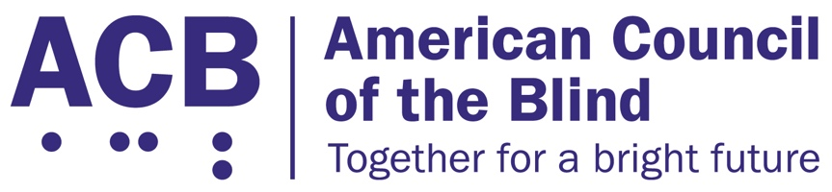
1703 N. Beauregard St., Suite 420

Alexandria, VA 22311

Tel: (202) 467-5081

Fax: (703) 465-5085

March 24, 2022

This letter is subsequent to the National Disability Rights Network-led coalition letter of March 17, 2022, which called for no expansion of the AbilityOne Program through the National Defense Authorization Act without program reforms with input from the disability community that the American Council of the Blind (ACB) co-signed. ACB would like to make clear our position on the AbilityOne Program and the associated non-profit agencies serving people who are blind and low vision. ACB prides ourself on our ability to work collaboratively with our partners in the blind and low vision community. However, we believe that it is time for this community to take a hard look at necessary reforms to modernize the AbilityOne Program to ensure its continued viability into the future.

ACB is a leading national consumer-driven advocacy organization for people who are blind and experiencing vision loss. Comprised of more than 65 state and special-interest affiliates, and in existence for more than 60 years, ACB strives to increase the independence, security, and equality of opportunity, and to improve quality of life, for all blind and visually impaired people in the United States. Integral to ACB’s mission of increasing independence and quality of life is ensuring equitable access to employment and vocational training for people who are blind and experiencing vision loss.

Since 1938, the Javits-Wagner-O’Day Act and the AbilityOne Program have sought to provide employment for people who are blind and low vision. Even with the passage of the Workforce Innovation and Opportunity Act, barriers persist that prevent people who are blind from achieving equal employment in the broader economy. In many cases, these barriers are based in the misconception that people who are blind are incapable of contributing fully in the workplace, or in the use of inaccessible workplace technology which impacts the productivity and success of employees with vision loss. As a result, the AbilityOne Program and the affiliated agencies still play an important role in providing vocational rehabilitation training and employment for people who are blind and low vision. For these reasons, ACB agrees with the AbilityOne Commission that the program should not be phased out, but should be modernized.

Currently, there are several initiatives under way to modernize the AbilityOne Program. ACB believes it would be improper to promote legislative or regulatory agendas to expand the AbilityOne Program while these reforms to modernize the program are pending; and, as the federal government considers proposals to modernize the AbilityOne Program, people with disabilities, including people who are blind and low vision, must be part of the conversation. To this end, we look forward to reviewing and commenting on the AbilityOne Commission’s draft Strategic Plan and collaborating with our partners to ensure the successful training and employment of people who are blind and low vision. In the coming week, ACB will share our priorities for AbilityOne modernization, and we look forward to scheduling formal and informal conversations to discuss these priorities with our partners and colleagues.

To join ACB in this initiative, please contact Clark Rachfal, ACB’s Director of Advocacy and Governmental Affairs: crachfal@acb.org, (202) 467-5081.

Sincerely,

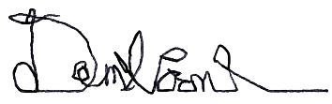
Dan Spoone
President

