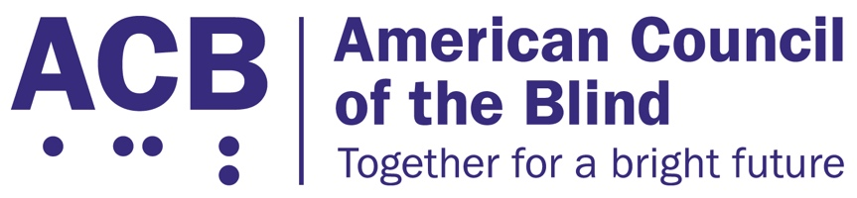
225 Reinekers Ln., Suite 660

Alexandria, VA 22314

Tel: (202) 467-5081

Fax: (703) 465-5085

June 16, 2026

American Hotel & Lodging Association
1250 Eye Street, N.W., Suite 1100
Washington, D.C. 20005

Dear Ms. Rosanna Maietta:

I write to you on behalf of the American Council of the Blind (ACB) to inform you about a resolution that was passed at our 2025 annual convention. Our members come together at our annual conventions to discuss issues impacting the blind community. The resolutions define advocacy work we hope to address. As discussed in the resolution shared below, we hope to work with the American Hotel and Lodging Association and its members to find ways to best accommodate blind and low vision customers when they patron hotels and motels across the United States. Blind patrons are often unable to read the print labels on toiletry bottles. We believe if we work together, we can find ways to make such products more accessible for our community. For instance, shampoo and conditioner bottles could be placed regularly in the same pattern so blind customers will know where to expect each item.

The American Council of the Blind is the nation’s leading member-driven organization of and for blind and low vision individuals. Founded in 1961 and comprised of 65 state and special-interest affiliate organizations, ACB strives to increase the independence, security, equality of opportunity, and to improve the quality of life for all people who are blind and experiencing vision loss.

We are confident we can find ways to accommodate blind and low vision customers so they can have a positive experience at your lodging places. Please review the resolution below. Then, we would like to find time in the next 30 days to talk about the situation and begin to brainstorm accommodation solutions. If you have any questions, please reach out to me at cstanley@acb.org, or at (202) 559-2041.

Sincerely,

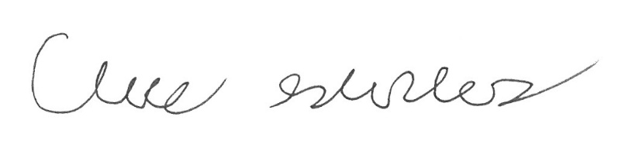

Claire Stanley, J.D.
Director of Advocacy and Governmental Affairs

Resolution 2025-02
Standardize Placement of Wall-Mounted Dispensers in Hotel Guest Rooms

Whereas, over the past several years, many hotels are providing personal care products such as shampoo, conditioner, soap, and lotion using wall mounted, reusable dispensers located in the shower and sink areas of hotel guest rooms; and

Whereas, there is no standard placement or order for how these dispensers are organized; and

Whereas, not having these dispensers placed in a standard order and location makes it difficult for hotel guests who are blind or low vision to know which dispenser is which; and

Whereas, this lack of consistency also makes it difficult for hotel staff to provide this information to guests who are blind or low vision;

Now, therefore, be it resolved by the American Council of the Blind in convention assembled virtually on June 24, 2025 that this organization work with the American Hotel and Lodging Association and major hotel chains to develop a procedure for the standard placement of reusable dispensers in the shower and sink areas of hotel guest rooms; and

Be it further resolved that copies of this resolution be sent to the President of the American Hotel and Lodging Association, and the heads of major hotel chains.

Adopted.

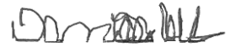

Denise Colley, Secretary

