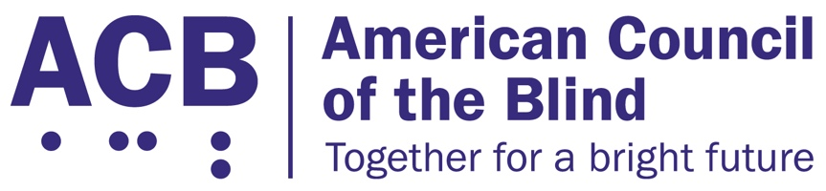225 Reinekers Ln., Suite 660

Alexandria, VA 22314

Tel: (202) 467-5081

Fax: (703) 465-5085

­

June 16, 2025

Secretary Chris Wright

U.S. Department of Energy

Office of Civil Rights and EEO

1000 Independence Ave., SW

Washington, D.C. 20585

Dear Secretary Wright:

The American Council of the Blind (ACB) urges the Department of Energy (DOE) to cease the adoption of the Direct Final Rule (DFR) scheduled for July 15, 2025. The outline of this draft explains that such a final rule can be postponed by a demonstration that it would have a significant or adverse effect. The DFR would do just that.

The American Council of the Blind is the nation’s leading member-driven organization of and for individuals who are blind or low vision. Founded in 1961 and comprised of thousands of members and 65 state and special-interest affiliate organizations, ACB strives to increase the independence, security, equality of opportunity, and to improve the quality of life of all individuals who are blind or experiencing vision loss.

The comment printed in the Federal Register explained that significant adverse comments oppose the rule and raise, alone or in combination, a serious enough issue related to each of the independent grounds for the rule that a substantive response is required. Based on this definition, we believe a substantive response from the DOE is necessary to explain how the proposal made by the DOE is likely to have significant and adverse effects on access for people with disabilities. Allowing entities who receive federal financial assistance to simply determine how to construct a building without following specific and long-enduring regulations is bound to lead to inaccessible facilities for people with disabilities. Therefore, we urge the DOE to rescind this DFR, and to provide a substantive explanation for these changes.

First, the DFR argues that the standards are unnecessary and unduly burdensome. These standards have been around for 45 years. In that time, entities have routinely complied with these regulations. The DFR provides no substantive data to demonstrate the unduly burdensome nature of the regulations. As a result, it has been shown that construction can fulfill these standards. Furthermore, the Rehabilitation Act of 1973, which included Section 504, includes an undue burden standard, which allows an entity to argue that a regulation is too difficult to carry out, whether for financial or other reasons. Therefore, a blanket unduly burdensome argument is unnecessary; a standard already exists to assess construction on a case-by-case basis. Again, past construction demonstrates that carrying out the standards are possible, and, if a specific situation arises, regulations already exist to assess that situation.

Furthermore, ACB believes that the DOE has failed to demonstrate how these regulations are unnecessary. Section 504 was created to make sure that millions of Americans have access to services that receive any kind of federal funding. This was the result of the inaccessibility of many goods and services. This lack of access made the regulations necessary. In this DFR, we see no explanation as to how such standards are unnecessary. The DFR talks about alternative methods to making their construction accessible, but it never provides examples to demonstrate the lack of necessity. It postulates that flexibility in the regulations allowing entities to deem what manner is most efficient should be adopted. However, this does not supersede the necessity of the regulations.

The DFR states that those who must make their buildings accessible need flexibility to comply with the law in the manner they deem most efficient. This is a dangerous assertion to claim for any legal requirements. If an entity covered by a law can determine what is the most efficient way to do so, efficiency may cut out variables such as safety and usability. Additionally, the definition here lets the business “deem” what is efficient. If the decision is made by the entity itself without a neutral third-party, many corners may be cut, again leading to unsafe and unusable constructions.

The DFR further argues that no one size fits all. Also this is ultimately true, basic generalizations can be made for the largest number of people. The U.S. Access Board, for instance, routinely conducts research to find what measurements for standards that impact the disability community will accommodate the largest number of people. These standards are made after numerous measurements and assessments. Yes, it will not perfectly fit every human being, but averages can be found to accommodate the greatest number of people. A simple argument that no one size fits all is a weak argument that will then make it less accessible for far more people.

The draft DFR argues that instead of set regulations, incentives should be provided for entities that make their constructions accessible. First, such incentives would have to be significant. Based on the price of construction, it’s unclear what financial costs a builder would prioritize; they may simply overlook an incentive. Furthermore, financial incentives do already exist for smaller entities. Tax credits exist by law to help smaller businesses to comply with laws like the Americans with Disabilities Act (ADA).

Finally, the potential effect that this new rule could have on construction is significant; entities who receive federal funding could argue that making any accommodations is simply unduly burdensome and refuse to accept any financial incentive to make the building accessible. As a result, more and more newly constructed buildings, or newly altered buildings, would become inaccessible for people with disabilities. This is not a small thing. As a result, this comments should have first been submitted to the Office of Information and Regulatory Affairs (OIRA). The DFR should not go into effect on July 15 without further action.

Thank you for the opportunity to submit our comments on this important issue. It is imperative that this direct final rule is not carried through with. If you have any questions, please reach out to me at [cstanley@acb.org](mailto:cstanley@acb.org), or at (202) 467-5081.

Sincerely,

Claire Stanley, J.D.

Director of Advocacy and Governmental Affairs

American Council of the Blind