
225 Reinekers Ln., Suite 660
Alexandria, VA 22314
Tel: (202) 467-5081
Fax: (703) 465-5085

July 2, 2026

Secretary Linda McMahon
U.S. Department of Education
400 Maryland Avenue SW
Washington D.C. 20202

Dear Secretary McMahon:

The American Council of the Blind (ACB) writes this letter to urge you to keep both the Office of Special Education and Rehabilitative Services (OSERS) and the Office of Civil Rights (OCR) within the U.S. Department of Education. The June 18, 2026 announcement to move the two offices to the U.S. Department of Health and Human Services (HHS) and the U.S. Department of Justice (DOJ) deeply concerns our community. We strongly believe these two new departments are not best equipped to administer these vital programs and services. Furthermore, the services administered through the Department of Education are pivotal to promote the lifelong success of blind and low vision individuals. We must do all we can to protect the programs that will yield such outcomes.

The American Council of the Blind is the nation’s leading consumer-driven organization of and for individuals who are blind and experiencing vision loss. Founded in 1961 and comprised of over 65 state and special interest affiliate organizations, ACB strives to increase the independence, security, equality of opportunity, and to improve the quality of life for all blind and low vision individuals. Integral to our mission is ensuring that persons who are blind or have low vision have access to both educational and employment opportunities.

Under the Individuals with Disabilities Education Act (IDEA), blind students have the right to a free and appropriate public education (FAPE). However, many students across the nation still struggle to receive such services in their local communities. OSERS was developed to help ensure that such rights are administered and protected. Similarly, the Rehabilitation Services Administration (RSA) exists to ensure that persons with disabilities can procure necessary services, training, and resources to become successfully employed. RSA is needed to make sure that such services are implemented in all fifty states through state vocational rehabilitation programs. These two agencies have the necessary skillsets and institutional knowledge to ensure that these pivotal services are administered. If the programs are suddenly shifted to HHS, the new agency will lack the specialized expertise to administered these important programs. As a result, blind and low vision persons are at great risk of losing these vital services. HHS exists to administer health-related programs. In contrast, educational and employment-related services are not healthcare services. We must do all we can to maintain and improve services that will bring about the success of students with disabilities.

We implore the Department of Education to retain OSERS and the OCR. We are happy to find time to set up a meeting to discuss these important issues. Please reach out with any questions. I can be reached at 202 559-2041 or at cstanley@acb.org.

Sincerely:
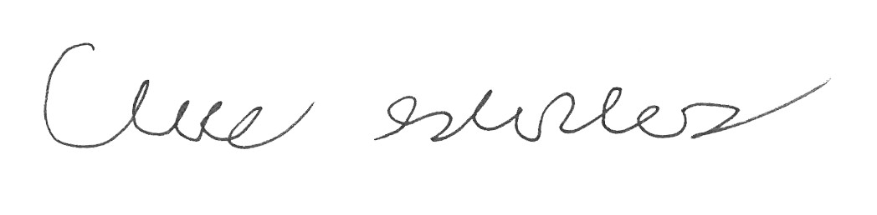
Claire Stanley, J.D.
Director of Advocacy and Governmental Affairs
American Council of the Blind

