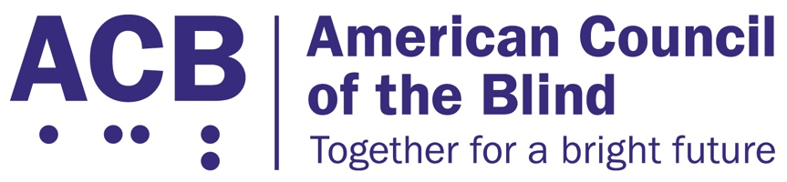
225 Reinekers Ln., Suite 660

Alexandria, VA 22314

Tel: (202) 467-5081

Fax: (703) 465-5085

February 3, 2026

Gregg M. Amore
82 Smith St.
Providence, RI 02903

Dear Secretary Amore:

We urge the Rhode Island legislature to pass Rhode Island House Bill H. 7007 and Senate Bill 2341. This very bill was passed in the state of Rhode Island two years ago. It simply expired due to a sunset provision at the end of December of 2025. This important bill ensures equal access voting rights for persons who are blind or have low vision.

The American Council of the Blind is the nation’s leading member-driven organization of and for individuals who are blind or have low vision. Founded in 1961 and comprised of thousands of members and 65 state and special-interest affiliate organizations, ACB strives to increase the independence, security, equality of opportunity, and to improve the quality of life of all people who are blind or experiencing vision loss.

The original law that was implemented two years ago replaced the fax machine and traditional mail as the only means of the voter returning a mail ballot by allowing the use of a federal government portal. The portal is the most secure in existence, and is currently used by the Department of Defense, Homeland Security, the Internal Revenue Service when collecting personal tax data, and the Department of Health and Human Services when securing private health documents. The law was implemented successfully after its passage two years ago and has been used in elections since then. There has been no evidence of breach, stolen ballots, or votes or any other abuse that opponents alleged would happen.

The most current academic research mimics the findings seen in recent Rhode Island’s elections. The research notes that a secure ballot portal, housed in a federally approved cloud, one approved by the CIA, DOD and NSA, is more secure than fax machines and email attachments.

As a result of this law, many Rhode Islanders were given the ability to vote privately and independently for the very first time. Numerous federal courts have ruled that all voters are entitled to the right to vote privately and independently; it is backed up by several pieces of federal law. Many states employ this method of electronic ballot return, including Massachusetts, New Hampshire and Vermont.

If these bills, (H-7007) and its Senate companion, are not passed, Rhode Island voters with disabilities will be forced to either vote in person at the polls, or print out their completed paper ballot and seek assistance from another person to return it via a home fax machine or addressing a paper envelope. Few persons now have fax machines in their homes. Furthermore, if a paper ballot must be placed in an envelope and put in the mail, a blind or low-vision individual cannot carry out the entire process privately and independently. The courts have ruled that all voters must be allowed to vote independently and privately, and requiring a blind person who may not have a printer/fax machine to purchase one is tantamount to the implementation of a poll tax.

Thank you for the opportunity to speak in favor of this bill. If you have any questions, please reach out to me at cstanley@acb.org, or at (202) 559-2041.

Sincerely,

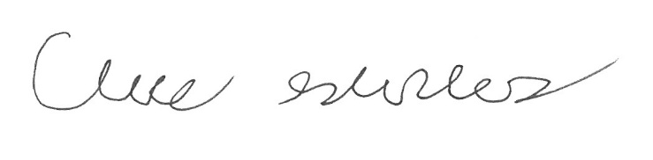
Claire Stanley, J.D.
Director of Advocacy and Governmental Affairs

