Audio Description Project Institute February 23-25, 2019

In Conjunction with the American Council of the Blind
2019 Presidents’ Meeting
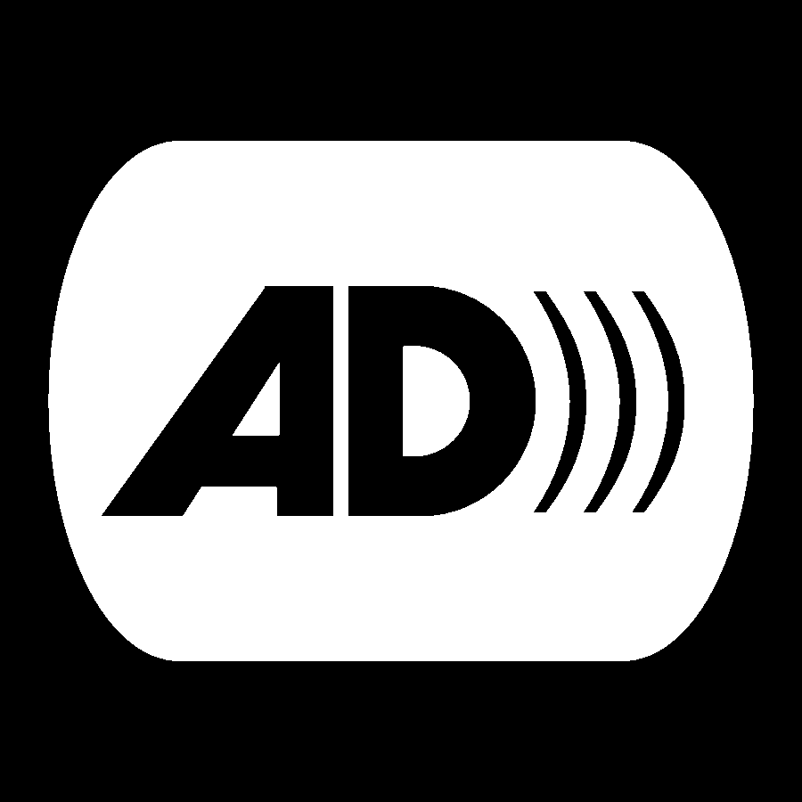
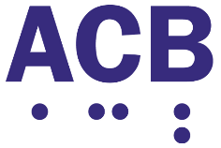
Crowne Plaza
Old Town Alexandria, VA

Registration Form

The registration form with payment needs to be mailed by February 8, 2019.
Attendees Name: ______________________________________________
Address: ______________________________________________________
City: _____________________________ State: _____ Zip: ______________
Country: _______________________
Phone: ____________________________ Email: _____________________________________
Please provide the following information if you need a purchase order
Purchase Order Number: ____________________________________
Company Name: ______________________________________________
Invoice Mailing Address: _____________________________________________
City, State, Zip: ________________________________________
2019 Audio Description Institute - February 23 - 25, 2019
____ Registration fee - $495

Please select one of the following February 25 lunch options:
____ Meat
____ Vegetarian
____ Specify Special Dietary Requirements _____________________________________

Make checks payable to: American Council of the Blind

Mail to: American Council of the Blind
6300 Shingle Creek Parkway, Suite 195
Brooklyn Center, MN 55430

Questions? Contact Joel Snyder at jsnyder@acb.org / 202-467-5083 or 301-920-0218

