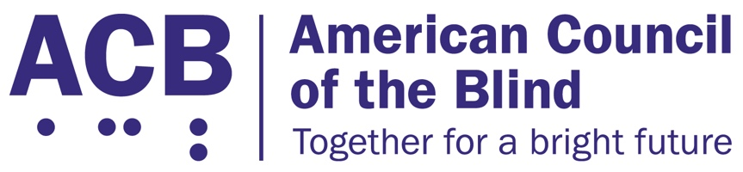
1703 N. Beauregard St., Suite 420

Alexandria, VA 22311

Tel: (202) 467-5081

Fax: (703) 465-5085

Exercise and Fitness for All Act Legislative Imperative

Background

Physical activity plays an important role in maintaining health, well-being, and quality of life. According to the Physical Activity Guidelines for Americans, 2nd Edition, physical activity can help control weight, improve mental health, and lower the risk for early death, heart disease, type 2 diabetes, and some cancers. Physical activity can also improve mental health by reducing depression and anxiety.

According to the Centers for Disease Control and Prevention (CDC), one in four U.S. adults is living with a disability, including 93 million Americans who are at high risk for severe vision loss. Adults with disabilities are more likely to have obesity, heart disease, stroke, diabetes, or cancer than adults without disabilities. Physical activity can reduce the risk and help manage these chronic conditions while improving daily living activities and independence. Physical activity can also reduce the risk of increased functional limitations.

The CDC recommends engaging in physical activity outdoors, such as walking, to improve physical and mental health. However, adults with disabilities report fewer accessible environmental supports, such as sidewalks, accessible pedestrian signals, public/paratransit and walkable shops, and more barriers, such as traffic, crime, and animals, for walking than those without disabilities. An alternative to outdoor physical activity is indoor exercise at a gym, fitness facility, or in a person’s home. However, the CDC also found that the inaccessibility of many fitness facilities creates barriers for those with a disability to exercise due to the lack of accessible space, instruction, and equipment.

Solution

In 2021, Senator Tammy Duckworth (D-IL) along with Senators Bob Casey (D-PA), Dianne Feinstein (D-CA), and Richard Blumenthal (D-CT) introduced the Exercise and Fitness for All Act (S. 2504) in the 117th Congress. This bill aims to make exercise equipment and fitness instruction fully accessible to people with disabilities. A bipartisan companion bill was introduced in the House of Representatives as H.R. 4756 by Representatives Mark DeSaulnier (D-CA) and Don Young (R-AK). Representative Dina Titus (D-NV) is also a co-sponsor. The bill:
- Requires the U.S. Access Board to establish guidelines relating to the number and types of accessible fitness equipment gyms and other fitness facilities are required to have;
- Requires the Department of Justice to publish regulations relating to the guidelines requiring fitness facilities to provide accessible equipment and instruction; and
- Ensures that there is at least one staff member at the facility that is trained in providing assistance to a person with a disability and in operating the accessible equipment.

Call to Action

ACB urges the House and Senate to pass the bipartisan Exercise and Fitness for All Act (S. 2504/H.R. 4756). When meeting with your member of Congress, be sure to describe the challenges that you have faced when attempting to use exercise and fitness equipment and explain what having access to accessible fitness facilities and equipment would mean to you as a person who is blind or experiencing vision loss.

For additional information related to this legislative imperative, please contact ACB’s Director of Advocacy and Governmental Affairs, Clark Rachfal, or ACB’s Advocacy and Outreach Specialist, Swatha Nandhakumar, by emailing advocacy@acb.org, or by calling (202) 467-5081.

