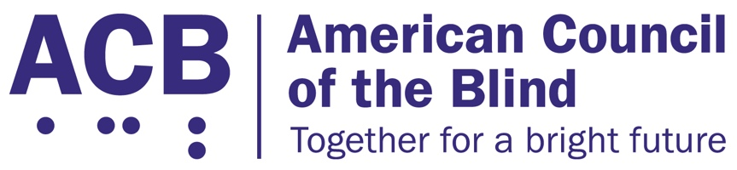
1703 N. Beauregard St., Suite 420

Alexandria, VA 22311

Tel: (202) 467-5081

Fax: (703) 465-5085

Website and Application Accessibility Act Legislative Imperative

Background

Being able to connect to and access websites, applications, and online services is growing increasingly crucial now, especially in light of the COVID-19 pandemic. With more than 313 million Americans saying they use the Internet, and about 81 percent of all Americans saying they access the Internet at least once a day, we have become dependent on online connectivity to do everything from attending school, performing the essential functions of a job, accessing entertainment, and interacting with businesses providing goods and services. People with disabilities, including those experiencing vision loss and blindness, are no exception. Most people with disabilities interact with websites, applications, and online services in the same ways as our non-disabled peers.

The majority of websites, mobile applications, and online services, however, are not accessible for individuals with disabilities, including individuals who are blind and experiencing vision loss. Many websites and mobile applications are not built to be compatible with assistive technology and software like screen readers and refreshable braille displays. Businesses that want to make their online content accessible to individuals with disabilities do not or claim to not have clear guidance as to how to achieve accessibility in the digital space.

While the Department of Justice has made it clear that the Americans with Disabilities Act does indeed apply to websites and online services, courts across the country have ruled differently and inconsistently. Whether and how much the ADA applies to the Internet depends on which court is involved and in which part of the country the cases are heard. It is incredibly clear that the current system of regulation through settlements, and not rule-making, does not do enough to protect the rights of people with disabilities in the online built environment.

Solution

The federal government, either through regulation or legislation, must create a uniform national framework to provide clear guidance for businesses and website developers to make their goods and services accessible and usable by people with disabilities, including those who are blind, low vision, and Deafblind.

Call to Action

ACB urges Congress to support the introduction and passage of a Website and Applications Accessibility Act, and in the clearest terms, to direct the Department of Justice to promulgate enforceable accessibility standards for websites, applications, and online services. Congress must provide DOJ with a clear timeline for when such standards are to be implemented, and these standards must include a strong definition of functional access that guarantees the ability for people who are blind and low vision to use and fully engage with websites, applications, and online services. When meeting with your member of Congress, please be sure to emphasize the need for website and mobile application accessibility. Share with them the routine barriers that you face when utilizing distance learning platforms, remote work and employee management systems, patient portals and electronic health records, government services, and all other forms of websites, applications and online services that people who are blind and all other people in the United States interact with on a daily basis. Please urge them to support a Website and Applications Accessibility Act, to create a uniform national framework for online accessibility, once introduced.

For additional information related to this legislative imperative, please contact ACB’s Director of Advocacy and Governmental Affairs, Clark Rachfal, or ACB’s Advocacy and Outreach Specialist, Swatha Nandhakumar, by emailing advocacy@acb.org, or by calling (202) 467-5081.

