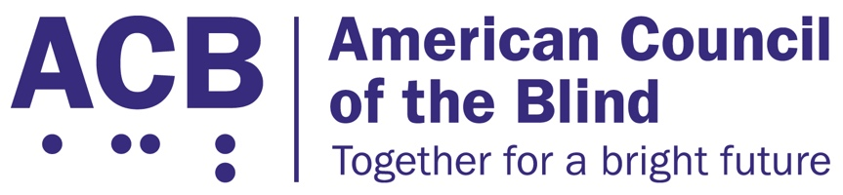
225 Reinekers Ln., Suite 660

Alexandria, VA 22314

Tel: (202) 467-5081

Fax: (703) 465-5085

June 16, 2026

Lions Clubs International
300 West 22nd Street
Oak Brook, IL 60523-8842

Dear International President Singh:

I write to you on behalf of the American Council of the Blind (ACB) to inform you about a resolution that was passed at our 2025 annual convention. Our members come together at our annual conventions to discuss issues impacting the blind community. The resolutions define advocacy work we hope to address.

The American Council of the Blind is the nation’s leading member-driven organization of and for blind and low vision individuals. Founded in 1961 and comprised of 65 state and special-interest affiliate organizations, ACB strives to increase the independence, security, equality of opportunity, and to improve the quality of life for all people who are blind and experiencing vision loss.

We wish to commend the Lion Clubs International on their work on behalf of people who are blind or have low vision. Helen Keller issued a challenge to the Lions to serve as “Knights of the Blind” one hundred years ago, and the American Council of the Blind wishes to commemorate that occasion and encourage the Lions to continue their work.

Please review the resolution below. If you have any questions, please reach out to me at cstanley@acb.org, or at (202) 559-2041. Thank you so much for your work supporting the blind and low vision community these past 100 years, and we look forward to the continuation of that work in the future.

Sincerely,

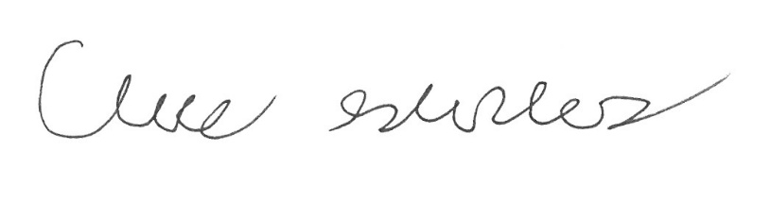

Claire Stanley, J.D.
Director of Advocacy and Governmental Affairs

Resolution 2025-03
Commemorating Knights of the Blind Challenge to Lions by Helen Keller

Whereas, on June 30, 1925, at the Lions International Convention in Cedar Point, Ohio, Helen Keller issued a challenge to Lions to serve as "Knights of the Blind;" and

Whereas, since that time, Lions across the United States and around the world have worked to eradicate preventable blindness, provide glasses and eye exams, conduct vision screenings, provide specialized equipment, sponsor camps, and many other activities; and

Whereas, it has been one hundred years since Helen Keller issued this challenge to Lions;

Now, therefore, be it resolved that the American Council of the Blind in convention assembled virtually on June 24, 2025 join together with the American Council of Blind Lions to commemorate 100 years of Lions accepting Helen Keller's challenge to serve as “Knights of the Blind;” and

Be it further resolved that together we urge Lions to continue their work on behalf of people who are blind or have low vision, working with organizations of and for the blind to not only prevent avoidable blindness but to follow Helen Keller's challenge "to make the lives of the blind more worthwhile everywhere by increasing their economic value and giving them the joy of normal activity;" and

Be it further resolved that a copy of this resolution be sent to Lions Clubs International.

Adopted.

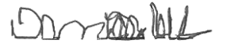

Denise Colley, Secretary

