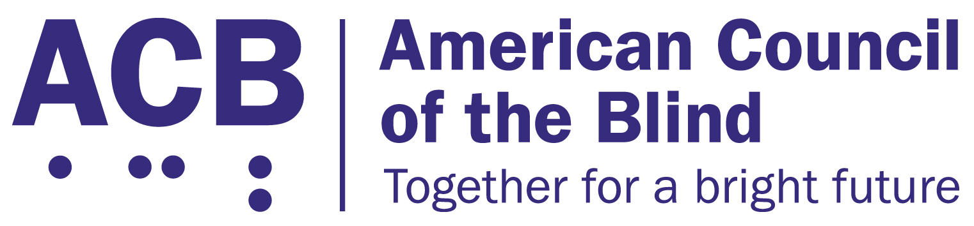
6200 Shingle Creek Pkwy, Ste 155
Brooklyn Center, MN 55430
612-332-3242 fax: 763-432-7562

MONTHLY MONETARY SUPPORT PROGRAM

Please use this form to enroll, change existing information, or to request that we contact you.
New Enrollment: _____ Change Existing Enrollment: _______
Name: ___________________________________________________________
Address: _________________________________________________________
_________________________________________________________________
City, State, Zip: ____________________________________________________
Telephone: ________________________________________________________
E Mail Address: ____________________________________________________
Deductions are made the 10th or the 22nd of each month. Please select the date each month you wish the deduction to occur:
10th Day: ________ 22nd Day: ________ Date to commence: _____________
For New Enrollees:
Enter your total monthly donation amount $____________________
For Changes to Your Existing Account (choose only one below):
increase my monthly donation by $ _______________
decrease my monthly donation by $_______________
Complete this section if you wish to assign a portion of your monthly donation to one state or special interest affiliate. Leave this section blank if you wish to contribute all your monthly donation to ACB:

Affiliate Name: ____________________________________________________
May we inform this affiliate of your donation? Yes: _____ No: _____
For New Enrollees
Enter amount you wish to designate (up to one half of monthly donation): $______________
For Changes to Your Existing Account (choose only one below):
increase my affiliate donation by $ _______________
decrease my affiliate donation by $ _______________
Complete this section if you wish to make your monthly donation via credit card:
Credit Card Type:
VISA: _______ Mastercard: _______ Discover: _______ American Express: _______
Credit Card Number: _______________________________________________
Expiration Date (month/year): ________________________________
Name as it appears on the card (if different from above): ___________________________________________________________
Complete this section if you wish to make your monthly donation via automatic monthly deduction from your bank account:

Checking: ________ Savings: _______
Bank Name: _______________________________________________________
Bank Address: _____________________________________________________
Bank City, ST, Zip: _________________________________________________
Bank Routing Number: ____________________(9 digits-usually to the left of account #)
Account Number: ________________________________________
The best way to ensure your bank account deduction is set up accurately is to write “void” on one of your checks and attach it to this form.
I hereby authorize the American Council of the Blind (ACB) to draft the amount indicated on this form, each month on the specified date, from my account or credit card as indicated below, as a contribution to ACB. ACB is further authorized to continue to draft funds, as set forth below, until I instruct ACB to alter or cancel this authorization. As an MMS participant, I understand that I can, at my sole option, designate a portion of my ACB monthly contribution (not to exceed one half) to one state or special interest affiliate of ACB, as designated below.
Please sign and date this form:
Authorized By: __________________________________Date: _____________
For Minneapolis Office Use Only
Previous Amount New
Amount of Change Amount Effective Date of Change:
ACB Portion ________ ________ ________ _________________
Affiliate Designation ________ ________ ________ Sponsor Recorded (if applicable):
Total Monthly Donation ________ ________ ________ ______________________________________

Processed By: ____________________________________ Date: ______________
MMS Revision 061518

