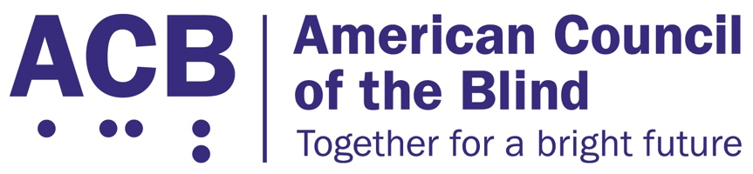
225 Reinekers Ln., Suite 660

Alexandria, VA 22314

Tel: (202) 467-5081

Fax: (703) 465-5085

March 26, 2026

The Honorable Senator Tim Scott The Honorable Senator Elizabeth Warren
Chairman Ranking Member
Senate Committee on Banking, Housing, Senate Committee on Banking, Housing,
and Urban Affairs Committee and Urban Affairs Committee
534 Dirksen Senate Office Building 534 Dirksen Senate Office Building
Washington, DC 20510 Washington, DC 20510

The Honorable Representative Sam Graves The Honorable Representative Rick Larsen
Chairman Ranking Member
Committee on Transportation & Infrastructure Committee on Transportation & Infrastructure
2165 Rayburn House Office Building 592 Ford House Office Building
Washington, DC 20515 Washington, DC 20515

RE: American Council of the Blind (ACB) Support for the Same-Day Paratransit Innovation Act

Dear Chair Scott, Chair Graves, Ranking Member Warren, and Ranking Member Larsen:

The American Council of the Blind, with over 8,000 members and 65 affiliates, writes to express our strong support for the Same-Day Paratransit Innovation Act and urge that it be included in the Surface Transportation Reauthorization bill. This important legislation addresses critical barriers to independence, employment, and full community participation for the approximately 7 million Americans with vision impairment and, more broadly, 18.6 million Americans, including veterans and seniors, with travel-limiting disabilities who rely on paratransit to reach essential destinations like jobs, schools, medical appointments, pharmacies, and grocery stores.

Despite this, current regulations under the Americans with Disabilities Act (ADA) only require agencies to provide paratransit service that offers trip scheduling at least 24 hours in advance, forcing riders to predict their health needs, work schedules, and other responsibilities at least a day ahead, effectively leaving us unable to respond to urgent issues and changing schedules such as a same-day doctor’s appointment or last-minute changes in work shifts. This inflexibility is about more than just inconvenience, it has tangible impacts on riders with disabilities’ health as missed rides mean missed medical appointments, medication pick-ups, missed care, and overall barriers to independence and remaining active members of our communities.

There is a better way: same-day paratransit. Modern technology exists to enable dynamic trip matching, real-time route optimization, and API-enabled multiple fleet integration, all of which facilitate same-day service and create efficiencies that help reduce per-trip costs even as the number of trips increase. As more and more transit agencies across the nation have considered offering same-day service, the Federal Transit Administration recognized the opportunity that this model presents in a 2023 Dear Colleague letter.
The Same-Day Paratransit Innovation Act encourages transit agencies to adopt modern technologies by providing partial relief for local cost share matching funds and flexibility in using federal operations funding for same-day services, removing financial hurdles. It would set minimum technology standards for accessibility, cybersecurity, and data interoperability, protecting transit agencies' data ownership and rider privacy, all informed by collaboration with paratransit riders, disability rights groups, the U.S. Access Board, and other stakeholders in developing these standards, ensuring rider input.
Thank you for your consideration and your continued commitment to advancing transportation access for all Americans, including blind and visually impaired riders. The Same-Day Paratransit Innovation Act encourages a solution that raises standards for riders while maintaining fiscal responsibility. We urge your Committees to include this critical legislation to advance transportation innovation and improve accessibility as part of the upcoming Surface Transportation Reauthorization.

Respectfully submitted,

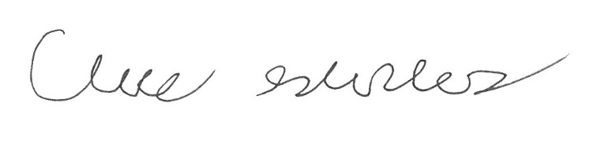
Claire Stanley
Director of Advocacy and Governmental Affairs
American Council of the Blind

