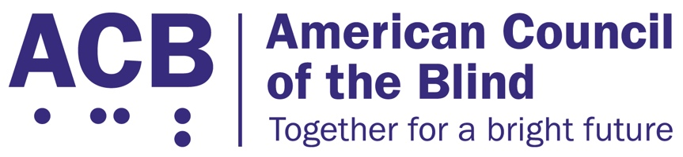
225 Reinekers Ln., Suite 660

Alexandria, VA 22314

Tel: (202) 467-5081

Fax: (703) 465-5085

June 30, 2026

U.S. Postmaster General
David Steiner
475 L’Enfant Plaza SW
Washington D.C. 20260

Dear Postmaster General Steiner:

We write to offer our thoughts on the potential policies in discussion by the U.S. Postal Service (USPS) in response to Executive Order 14399 from March of 2026. The American Council of the Blind (ACB) believes these new policies may disproportionately impact persons with disabilities and urges the USPS to help ensure that all Americans have equal access to vote. The right to vote in local and national elections is a fundamental right and the blind and low vision community must have equal access to the ballot box.

The American Council of the Blind is the nation’s leading member-driven organization of and for individuals who are blind or experiencing vision loss. Founded in 1961 and comprised of more than 65 state and special-interest affiliate organizations, ACB strives to increase the independence, security, equality of opportunity, and to improve the quality of life for all blind and low vision individuals, including our thousands of members. The right to vote is a fundamental right in the United States and one we fight to protect.

Mail in and absentee voting has long been a vital voting process for people who are blind or have low vision. Transportation remains a significant barrier for this population. The lack of accessible and affordable public transportation options prevents many blind individuals from getting around their communities. As a result, traveling to a voting location can be extremely difficult, and voting via mail becomes necessary. If the process of registering to vote through the mail or absentee process becomes more weighed down by additional regulations, this will disproportionately impact people who are blind or have low vision. A whole segment of the community may be kept from participating in our democracy via the voting process.

The new policies are also likely to create a plethora of technical errors. As people are required to submit more documentation, technical errors are inevitable. Access barriers will once again make remedying these errors disproportionately more difficult to solve for people who are blind or have low vision. Likewise, access barriers to transportation will make it more difficult to procure proper documentation or to visit necessary government offices.

Additionally, the process of fixing such technical errors may create greater hurdles to surpass for people who are blind. For instance, if an online portal is developed, there is fear that such a portal will be inaccessible for people who use screen reading software. This is already a current problem for numerous websites. With an inaccessible online portal, people who use screen reading software will not be able to independently and quickly remedy the problem which threatens to disenfranchise them entirely.

Moreover, the new policies may significantly decrease the amount of time voters will have to remedy any existing technical errors. If blind or low vision individuals cannot access the website or travel to the necessary building independently, they will have to wait to get help from others. With the very short time span provided to fix such problems, the person is likely to lose the opportunity to vote.

Finally, disability is one the minority community any person can become a member of at any time. A person may become ill or be in an accident and suddenly lose their vision. At that time, accommodation will be necessary for this newly disabled person to exercise their right to vote. However, if these new burdensome policies are put in place, the newly disabled person will not have the processes in place to vote via mail or absentee, especially if compliance with the new requirements takes an exorbitant amount of time.

Thank you for the opportunity for ACB to offer our thoughts on the likely barriers that will arise with the implementation of the newly proposed processes and procedures. We urge the USPS to not implement these burdensome requirements. If you have any questions, I am happy to speak with you. I can be reached at 202 559-2041 or at cstanley@acb.org.

Sincerely:
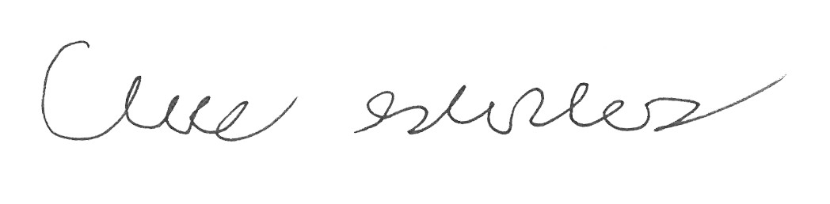
Claire Stanley J.D.
Director of Advocacy and Governmental Affairs
American Council of the Blind

