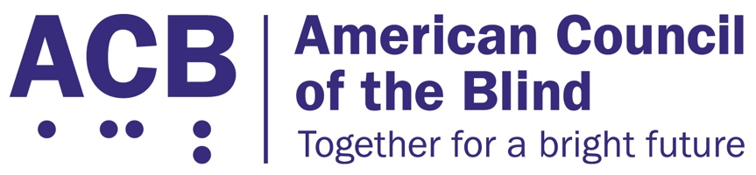
225 Reinekers Ln., Suite 660

Alexandria, VA 22314

Tel: (202) 467-5081

Fax: (703) 465-5085

March 24, 2026

The Honorable Jonathan Morrison
Administrator
National Highway Traffic Safety Administration
1200 New Jersey Avenue SE, West Building
Washington, DC 20590

RE: Support for Zoox’s petition, Docket No. NHTSA-2025-0523
Dear Administrator Morrison:

The American Council of the Blind (ACB) is a national member-driven organization that advocates for the civil rights, independence, and equality of people who are blind or visually impaired. We work to eliminate barriers to things such as transportation, education, employment, and technology while providing resources, scholarships, and a supportive community. On behalf of ACB, I offer our support for Zoox’s petition, Docket No. NHTSA-2025-0523, requesting an exemption to enable commercial deployment of their automated vehicles under strict federal safety monitoring.

As an organization working to advance accessible and inclusive transportation, we recognize the transformative potential of autonomous vehicle technologies to expand safe, reliable mobility for individuals who are blind, have low vision, or cannot drive due to other disabilities. For millions of Americans, lack of accessible transportation remains one of the greatest barriers to employment, education, healthcare, and community participation. Zoox’s purpose-built autonomous vehicle represents an important step toward equitable access and greater independence for people who have historically been excluded from traditional transportation systems. Our members are overwhelmingly excited about the inclusion of transportation resources like Zoox in their communities.

By combining full electrification with advanced automation and thoughtful vehicle design, Zoox’s approach has the potential to provide on-demand, door-to-door service that enhances autonomy and dignity for riders with disabilities. We are encouraged by Zoox’s commitment to safety, transparency, and engagement with the disability community to ensure these systems meet real-world accessibility needs. Several of our members have already had the opportunity to test the Zoox vehicle and offer input on how the transportation resource can accommodate and benefit our community.

Autonomous vehicle technology is a step forward toward creating a more accessible, efficient, and inclusive transportation system across the United States. We strongly support Zoox’s efforts to responsibly develop and deploy autonomous vehicles that expand access, reduce transportation barriers, and advance mobility equity for all. These innovations bring us closer to a future where every person — regardless of vision or physical disability — can travel safely, independently, and with confidence.

For these reasons, we support Zoox’s petition to permit the safe and responsible commercial operation of its autonomous vehicles. Thank you for your commitment to advancing innovation in a way that promotes safety and inclusion. We look forward to continuing to work with NHTSA and industry partners to ensure autonomous mobility benefits all Americans. Please reach out if you have any questions. I can be reached at (202) 559-2041 or at cstanley@acb.org.
Sincerely,

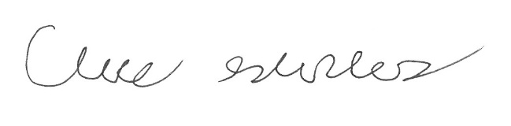

Claire Stanley, J.D.
Director of Advocacy and Governmental Affairs

