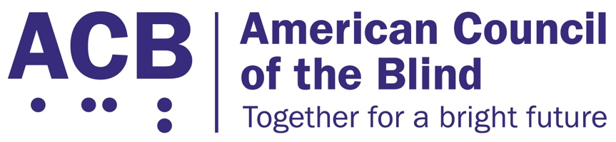
225 Reinekers Ln., Suite 660

Alexandria, VA 22314

Tel: (202) 467-5081

Fax: (703) 465-5085

Senator Monica Martinez
250 Veterans Hwy.
Hauppauge, NY 11788

Dear Senator Martinez:

I write on behalf of the American Council of the Blind (ACB) to urge the New York state legislature to pass Senate bill 1740 to ensure digital access to prescription bottles to make healthcare access more accessible for persons who are blind or have low vision. We ask that you encourage your fellow state senators to swiftly move this bill forward. Access to one’s medication is an essential need for our community.

The American Council of the Blind is the nation’s leading member-driven organization of and for blind and low vision individuals. Founded in 1961 and comprised of thousands of members and 65 state and special-interest affiliate organizations, including ACB of New York, ACB strives to increase the independence, security, equality of opportunity, and to improve the quality of life of all people who are blind or experiencing vision loss. Integral to this mission is ensuring and advocating for equitable access to healthcare and other medical services.

It is estimated that 125,000 medical errors take place each year in the state of New York. Because of health privacy laws, it is unclear how many of those are a result of access barriers. However, anecdotally, it is known that persons who cannot independently read their medication bottles are at greater risk of taking the wrong medication or dosage. This risk can easily be eliminated through the provision of digital prescription readers.

The bill, which was introduced in January of 2025, calls for the development of digital prescription labels for persons who are blind or have low vision. The bill would call for the distribution of a third-party device that can read medication labels for those who cannot read them visually. The devices would have to be made available upon request by those in need of such a service. Additionally, pharmacies will be charged with making a valid effort to inform their clients of the service. The device would be of no cost for its users.

Such a simple device will empower persons with vision disabilities to remain independent and maintain their own healthcare. Similar laws and processes exist in numerous other states across the nation. With the various forms of technology we have at this time, there is no excuse for not providing such technology to promote health and independence.

I would be happy to talk about the issue further and discuss how such technology has changed the lives of blind and low-vision people in other states. You can contact me at (202) 559-2041, or at cstanley@acb.org.

Sincerely,

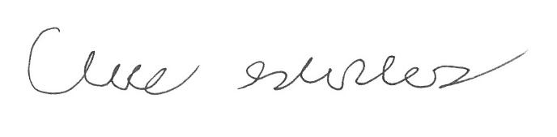

Claire Stanley, J.D.
Director of Advocacy and Governmental Affairs

